1. Baycrest Accessibility Plan 2021-2026 Introduction

Ensuring that Baycrest is accessible to as many people as possible has always been important. This is a dynamic document that ensures Baycrest is continually striving to identify and remove all barriers that prevent a person with disabilities from fully participating in our facilities, programs and services, policies and practices.
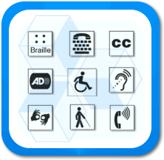
Our approach to accessibility also goes beyond the identification and removal of barriers. It includes advocacy, education and research, as well as our provision of care and treatment which is guided by our vision to transform the experience of aging through leading innovations in brain health, wellness promotion, and approaches to care that enrich the lives of older adults.

2. Aims and Objectives of Baycrest´s Approach to Accessibility
At Baycrest we are committed to providing respectful care that focuses on the unique needs of the individual. Providing equitable care that respects the dignity and independence of people with disabilities is a priority.
Integrated into the fabric of Baycrest and its "Values" is "Respect". Respect comes with the understanding that each person is unique with intrinsic dignity and worth.
"Baycrest will continually strive to identify and remove all barriers that prevent a person with disabilities from fully participating within our facilities, programs and services, policies and practices."
Barriers refer to physical, architectural, informational or communicative, attitudinal, technological, policy, and practice.
(see Appendix A).
Disabilities include physical, hearing, speech, vision, deaf-blind, smell, taste, touch, intellectual, mental health, and learning.
(see Appendix B).
As a health care provider, Baycrest´s approach to accessibility goes beyond the identification and removal of barriers. It also includes advocacy, education and research, as well as the provision of care and treatment as guided by our Vision of “a world where every older adult lives a life of purpose, inspiration and fulfilment.” Baycrest also has a history of offering volunteer opportunities to persons who have a variety of special needs.
This multi-year accessibility plan applies to Baycrest Centre for Geriatric Care, Baycrest Hospital, The Jewish Home for the Aged and The Baycrest Day Care Centre (collectively, “Baycrest”), together with any affiliated departments or entities. This plan also applies to The Baycrest Centre Foundation.
The multi-year accessibility plan will help Baycrest’s ongoing efforts to meet the requirements of the Accessibility for Ontarians with Disabilities Act (AODA), including the Integrated Accessibility Standards Regulation (Ontario Regulation 191/11). Baycrest’s multi-year accessibility plan is coordinated and approved by the Accessibility Committee.

3. Description of Baycrest
Baycrest is comprised of a number of facilities, programs and services. The campus is located on 22 acres of land on Bathurst Street in Toronto. It comprises a total of six buildings which add up to 1.3 million square feet of physical space.
Approximately 1100 patients and residents live at Baycrest, and a number of outpatients, family members and other visitors who visit Baycrest on a daily basis. Approximately 1800 staff and over 2000 volunteers work and volunteer at Baycrest. Students, contractors and other members of the public also frequent Baycrest on a daily basis.
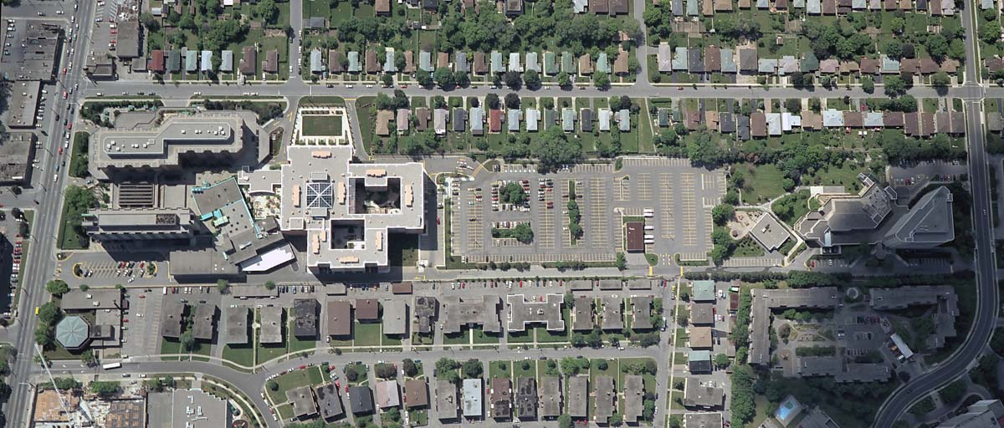

Main Complex

Baycrest Hospital
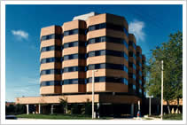
A seven-storey, 365,000 square foot building built in 1985. The 300-bed Hospital specializes in Rehabilitation, Mental Health, and Complex Continuing Care. There are onsite Ambulatory Clinics, including outpatient services.

Apotex Centre Jewish Home for the Aged
A seven-storey, 388,000 square foot building built in 2000. The 472-bed Apotex Centre is a long-term care facility with the 7th floor specializing in residents with stroke and/or cognitive impairment.
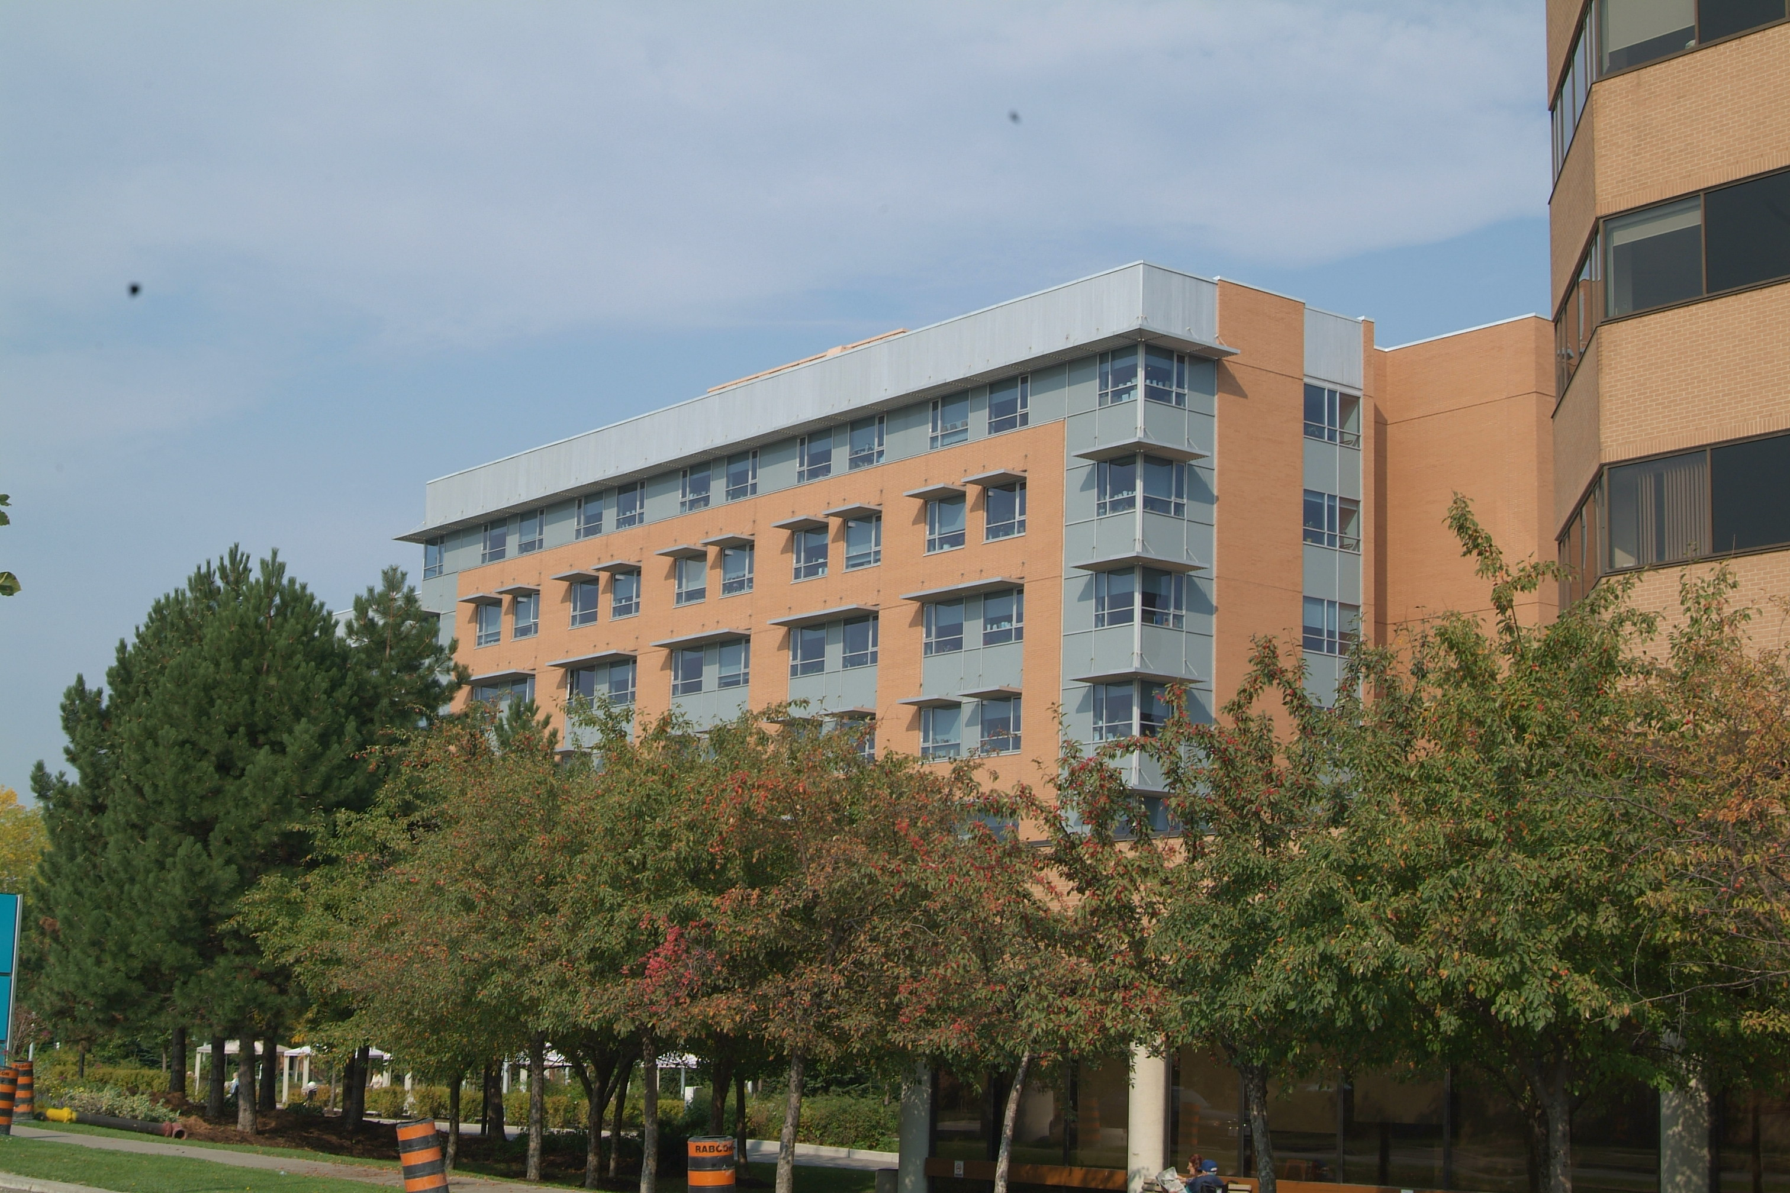
Posluns Building
A four-storey, 50,000 square foot building built in 1954. The 1st and 2nd floors are used by Support Services to house the food services and receiving dock operations. The 3rd and 4th floor are office related clinical areas and are visited by outpatients attending appointments.

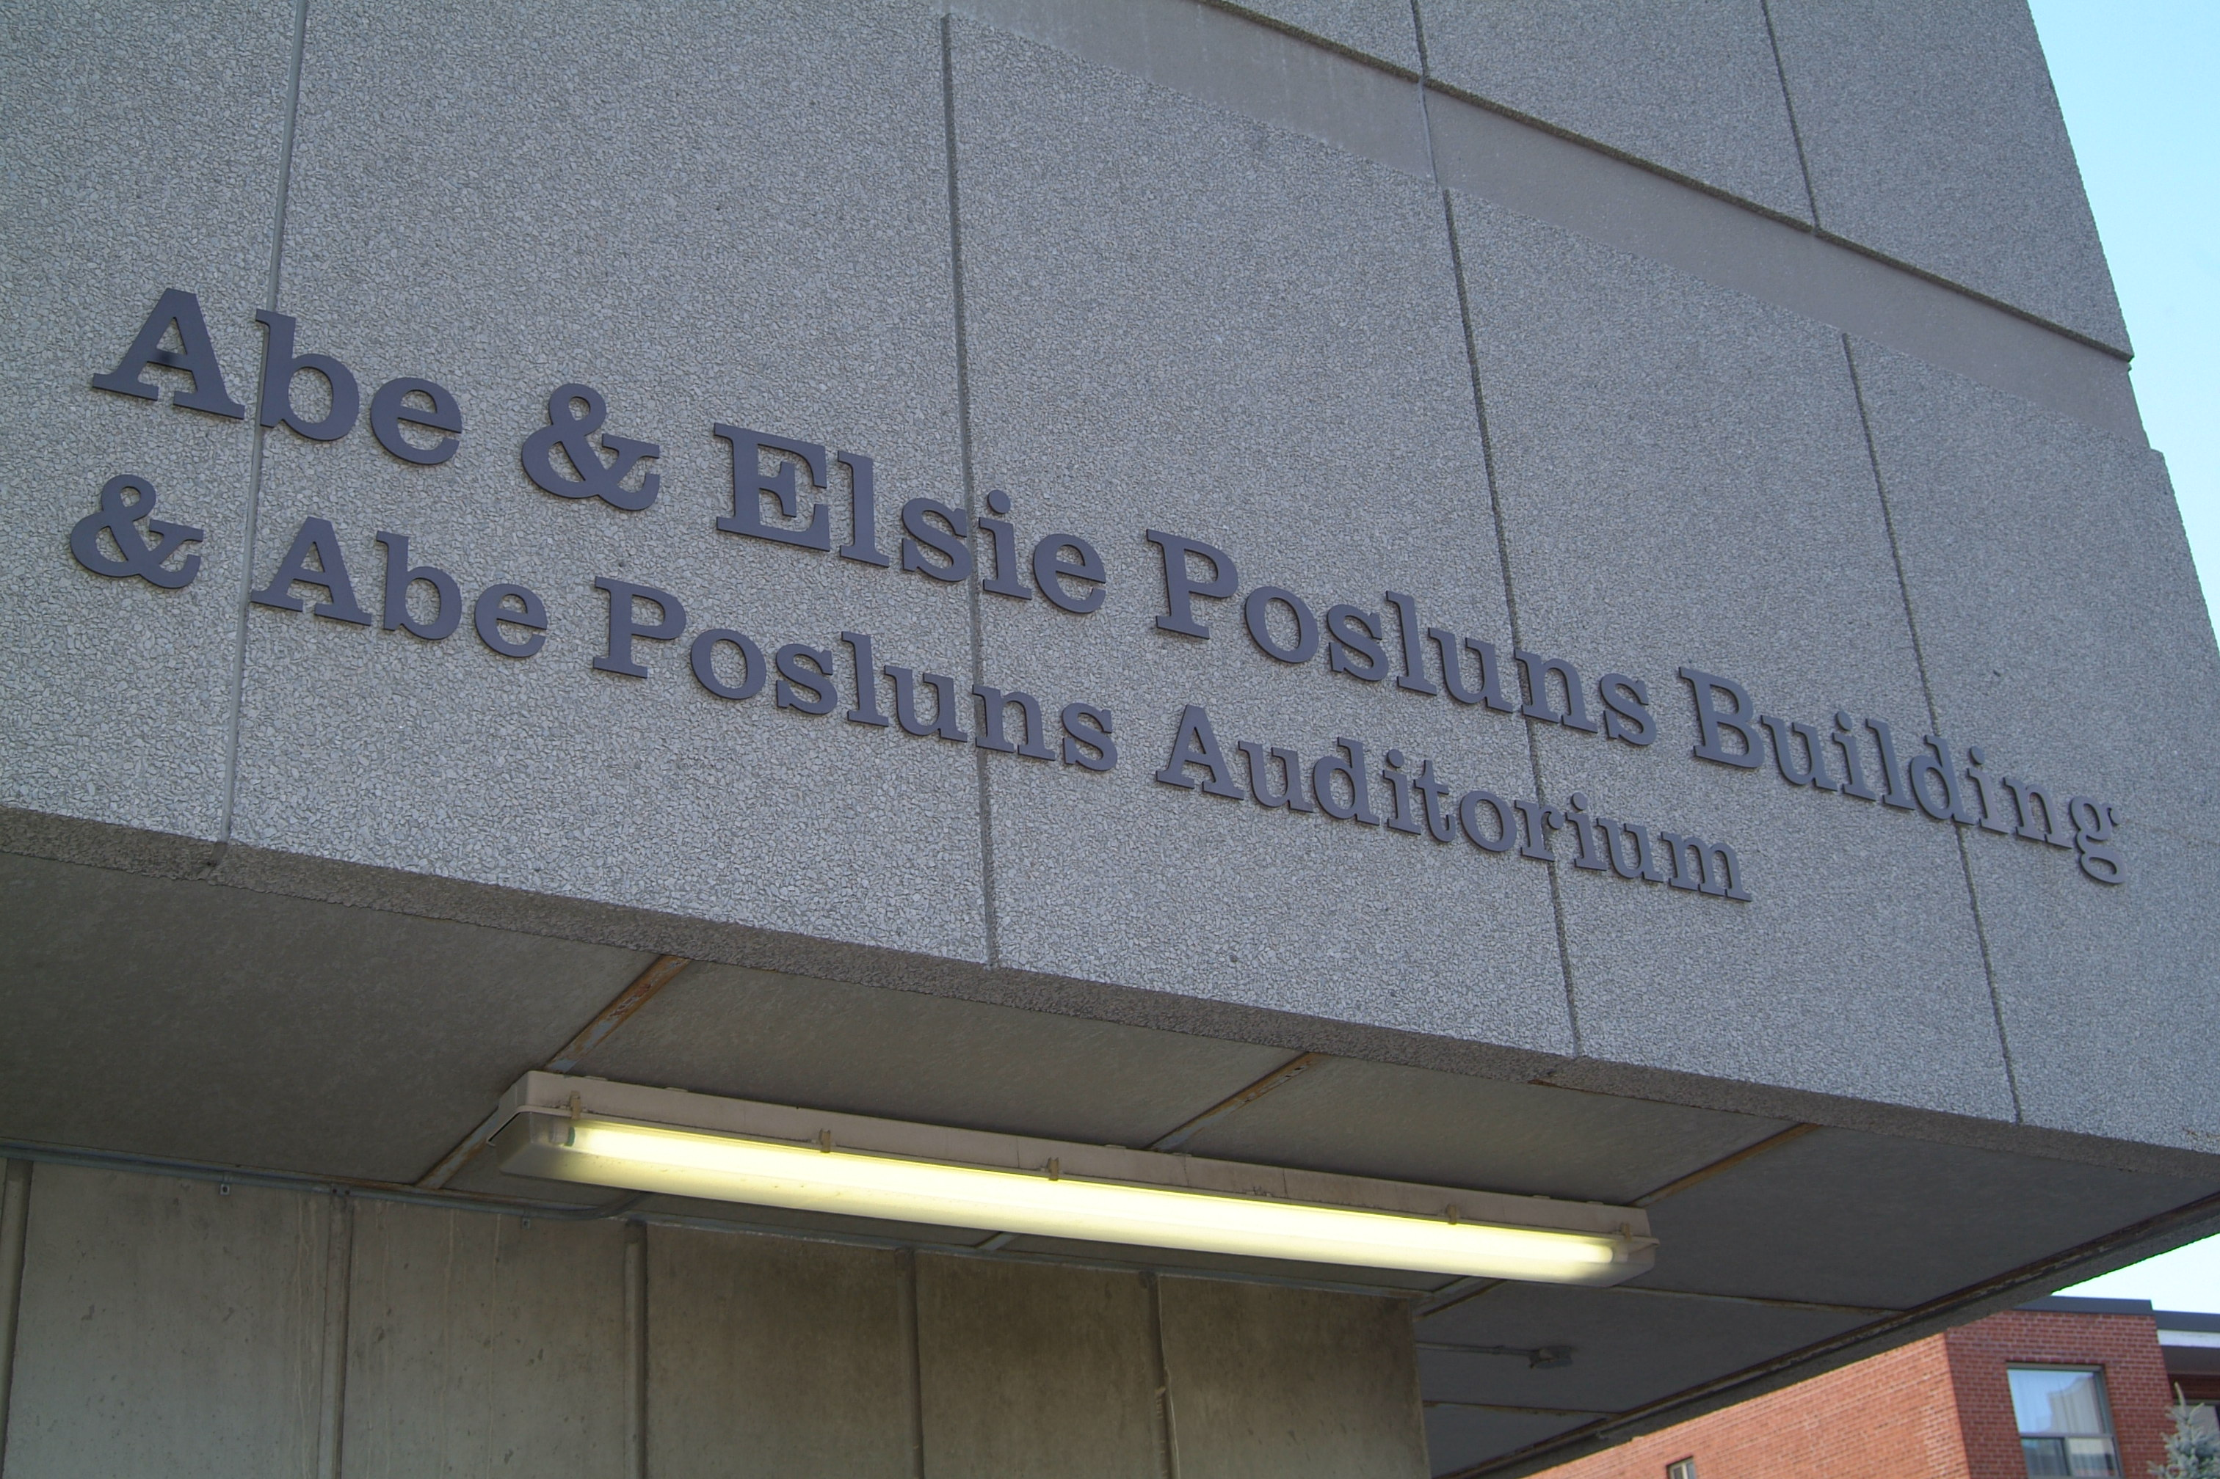

Kimel Family Building
A ten-storey, 256,000 square foot building built in 1967. The upper floors are used by Research, with primarily office and test/lab facilities. Research subjects will visit the area as per appointment.
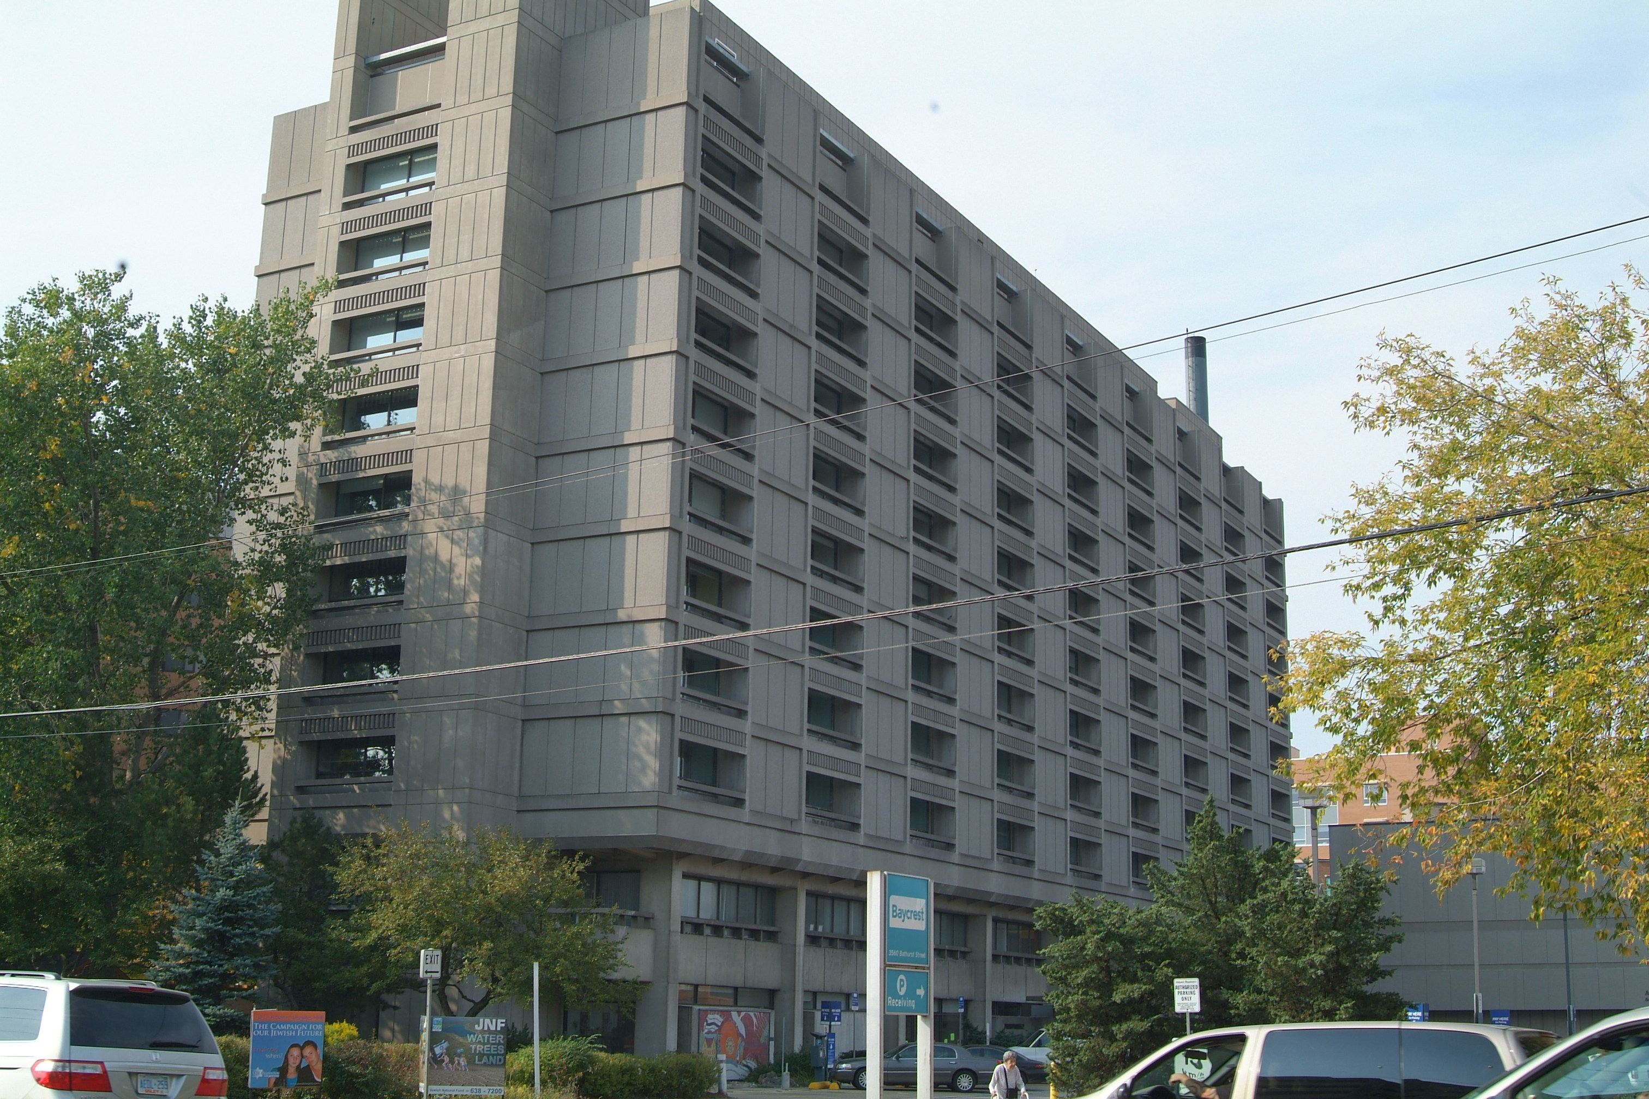
The middle floors are used as clinical areas. Outpatients will visit the area as per appointment. The lower floors are used as office areas.

Terraces of Baycrest

Terraces of Baycrest
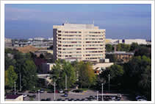
An eleven-storey, 172,000 square foot building built in 1976. The building provides supportive housing to approx. 150 residents.
Esther Exton Childcare Centre
A one-storey, 5000 square foot building built in 1995. The facility provides daily childcare services.
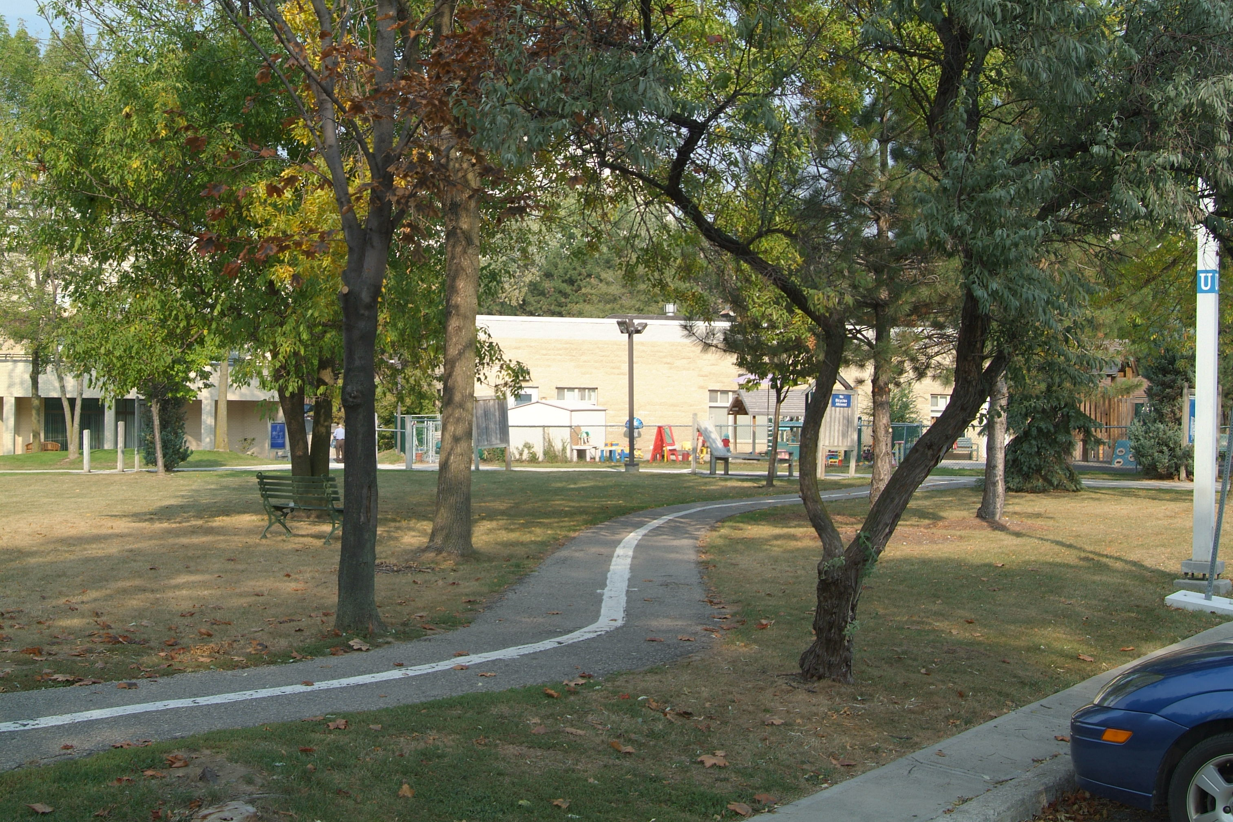

Grounds
The property has a number of park-like settings for outdoor enjoyment.
A paved walking path is used to connect the Main complex with the Terraces of Baycrest.
There are a total of 712 car park spaces located throughout the campus. There is a main car park located between the Main complex and the Terraces of Baycrest. There are also a number of car park spaces attached to each building facility, excluding the hospital building. Thirty (30) of the 712 spaces are designated as accessible parking.
Public transit is available at the entrance to the campus on Bathurst Street.
Baycrest offers a daily Shuttle Bus service throughout the campus property.
Baycrest offers a bus service to transport clients to and from the Community Day Centre for Seniors.
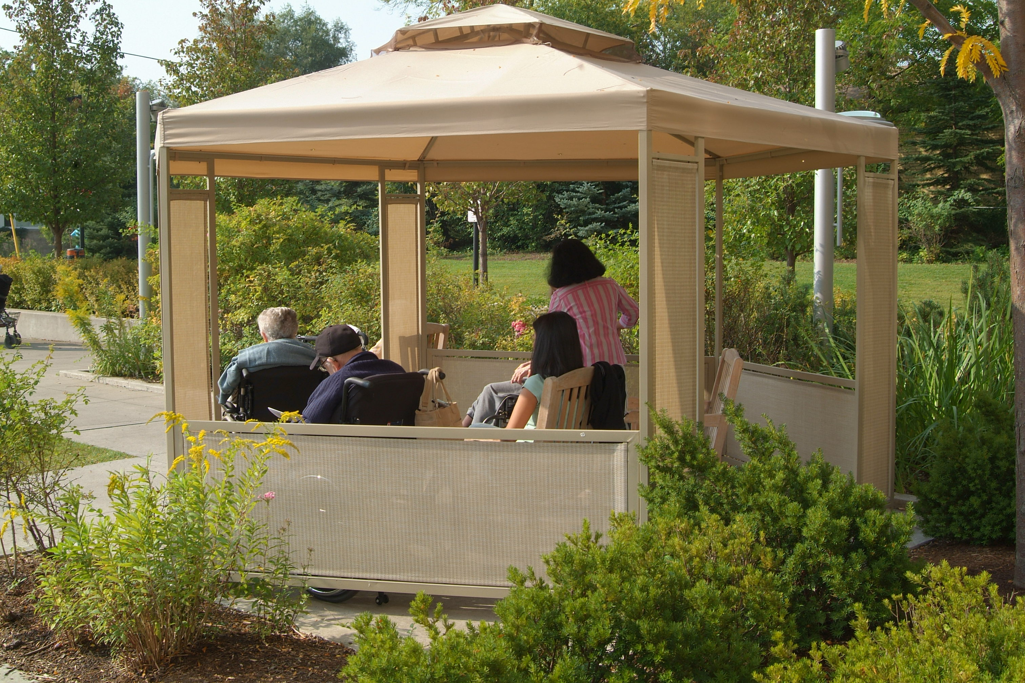

4. Accessibility Committee

Terms of Reference
Purpose
The Accessibility Committee is accountable for identifying and removing barriers to advance accessibility at Baycrest. This Committee provides a forum to meet Baycrest’s mandate as set out in the Accessibility for Ontarians with Disabilities Act, 2005 (“AODA”), other relevant legislation and established standards. This includes:
1. Support compliance and implementation of the AODA and standards prescribed by its regulations.
2. Identify, access and promote awareness of accessibility challenges at Baycrest and work with senior management to find solutions.
3. Recommend the measures necessary for compliance with the AODA, and other relevant legislation and established standards.
4. Conduct an inventory of current compliance measures which exist at Baycrest.
5. Report on annual accomplishments and strategies with respect to increasing accessibility at Baycrest.
Chair:
- Legal Affairs

Composition (in addition to the Chair):
- Audiology
- Speech Language Pathology
- Human Resources
- Marketing and Communications
- Occupational Therapy
- Redevelopment and Support Services
- Volunteer Services
- Member from the Community

Authority/Reporting Relationship:
The Accessibility Committee reports to the Operations Steering Committee.
Meeting Frequency:
The Accessibility Committee will meet quarterly, or as deemed necessary by committee members. Meetings may be required on a more frequent basis to address particular issues.
5. Multi-Year Plan to meet requirements under the Integrated Accessibility Standards Regulation (IASR)
REQUIREMENT | LEAD | YEAR  REQUIRED | STATUS

GENERAL
Accessibility Policies  - Develop, implement and maintain policies governing how Baycrest achieves accessibility through meeting its requirements referred to in the Regulation. | Committee | 2013 | Complete.
Accessibility Plans  - Establish, implement, maintain and document a multi-year accessibility plan which outlines Baycrest’s strategy to prevent and remove barriers. | Committee | 2013 | Complete.
Procuring or acquiring goods, services or facilities  - Incorporate accessibility criteria and features when procuring or acquiring goods, services, or facilities, except where it is not practicable to do so. | Finance  Redevelopment and Support Services | 2013 | Complete.  - Accessibility compliance incorporated in procurement process.
Self Service Kiosks  - Incorporate accessibility features when designing, procuring or acquiring self-service kiosks. | Redevelopment and Support Services  Volunteer Services | 2013 | Complete.  - Review conducted with stakeholders.
Training  - Training on the requirements of the accessibility standards in the IASR and the Human Rights Code as it pertains to persons with disabilities. | Committee | 2014 | Ongoing  - Included in Baycrest’s Core Curriculum; specialized additional training offered as appropriate in light of duties.

INFORMATION AND COMMUNICATION STANDARDS
Feedback  - Ensure feedback processes are accessible to persons with disabilities by providing or arranging for the provision of accessible formats and communications supports, upon request.  - Notify public about availability. | - Human Resources  - Marketing and Communications  - Organizational Effectiveness  - Volunteer Services | 2014 | Complete  - Review conducted with stakeholders.
Accessible formats and communication supports  - Upon request, provide or arrange for the provision of accessible formats and communication supports for persons with disabilities in a timely manner.  - Notify the public about the availability of accessible formats and communication reports. | Marketing and Communications (accessible formats)  Audiology (communication supports) | 2015 | Complete
Emergency procedures, plans or public safety information | Emergency Management and Security | 2012 | Complete  - Information available upon request as soon as practicable.
Accessible websites and web content  - Make internet websites and web content conform with the World Wide Web Consortium Web Content Accessibility Guidelines (WCAG) 2.0, initially at Level A and increasing to Level AA.  - 2014: New internet websites and web content on those sites must conform with WCAG 2.0 Level A.  - 2021: All internet websites and web content must conform with WCAG 2.0 Level AA, other than (i) success criteria 1.2.4 Captions (Live); and (ii) success criteria 1.2.5 Audio Descriptions (Pre-recorded). | Marketing and Communications | 2014  2021 | Complete  - New web content on www.baycrest.org conforms to WCAG 2.0, Level A.  Complete www.baycrest.org and www.baycrestfoundation.org

EMPLOYMENT STANDARDS
General Recruitment  - Notify employees and the public about the availability of accommodation for applicants with disabilities in the recruitment process. | Human Resources | 2014 | Complete  - Notice provided on job postings and on applicable websites.
Recruitment, assessment or selection process  - Notify applicants that accommodations are available upon request in relation to the materials or processes to be used.  - If selected applicant requests an accommodation, provide suitable accommodation in a manner that takes into account the applicant’s accessibility needs. | Human Resources | 2014 | Complete  - Notice provided through email and other forms of communication with applicants.
Notice to successful applicants | Human Resources | 2014 | Complete  - Notice provided in offer letters.
Inform employees of employer’s policies used to support its employees with disabilities | Human Resources | 2014 | Complete  - Policies are updated.
Accessible formats and communication supports for employees  - Where requested, employer shall provide accessible formats and communication supports for (a) information that is needed in order to perform the employee’s job; and (b) information that is generally available to employees in the workplace. | Human Resources | 2014 | Complete  - Policies are updated.
Workplace emergency response information to employees  - Provide individualized workplace emergency response information to employees who have a disability if individualized information necessary and employer is aware of need for accommodation.  - Information shall be provided as soon as practical after the employer becomes aware of the need for accommodation. | Emergency Management and Security | 2014 | Complete  - Information provided by Emergency Management and Security Services, working with the Occupational Health and Safety Department.
Documented individual accommodation plans | Human Resources | 2014 | Complete  - Policies are updated.
Documented return to work process | Human Resources | 2014 | Complete  - Policies are updated.
Performance management  - Performance management shall take into account the accessibility needs of employees with disabilities, as well as individual accommodation plans. | Organizational Effectiveness | 2014 | Complete  - Policies are updated.  - Accessibility needs are assessed on an individualized basis.
Career development and advancement  - Career development and advancement shall take into account the accessibility needs of its employees with disabilities as well as any individual accommodation plans. | Organizational Effectiveness | 2014 | Complete  - Policies are updated.  - Accessibility needs are assessed on an individualized basis.
Redeployment  - Redeployment shall take into account the accessibility needs of employees with disabilities, as well as individual accommodation plans. | Human Resources | 2014 | Complete  - Policies are updated.  - Accessibility needs are assessed on an individualized basis.

TRANSPORTATION STANDARDS

Other transportation services – public sector organizations  - Provide accessible vehicles or equivalent vehicles upon request | Residential Living and Community Programs | 2011 | Complete  - Accessible shuttle buses are provided.

DESIGN OF PUBLIC SPACES STANDARDS (BUILT ENVIRONMENT)

Outdoor public eating areas | Redevelopment and Support Services | 2016 | Mandatory requirement for any new or redeveloped spaces (if applicable)
Exterior paths of travel | Redevelopment and Support Services | 2016 | Mandatory requirement for any new or redeveloped spaces (if applicable)
Parking | Redevelopment and Support Services | 2016 | Mandatory requirement for any new or redeveloped spaces (if applicable)
Maintenance  - For accessible elements in public spaces, procedures required for preventative and emergency maintenance; and for dealing with temporary disruptions. | Redevelopment and Support Services | 2016 | - Notice is provided when maintenance occurs, including information about alternatives.  - Signage is put up explaining temporary disruptions and outlining alternatives.
Service counters, fixed queuing guides and waiting areas | Redevelopment and Support Services | 2016 | Mandatory requirement for any new or redeveloped spaces (if applicable)

CUSTOMER SERVICE STANDARDS

Policies  - Develop, implement and maintain policies governing how Baycrest provides goods, services or facilities to persons with disabilities. | Committee | 2010 | Complete
Use of service animals and support persons | Committee | 2010 | Complete
Notice of temporary disruptions | Redevelopment and Support Services | 2010 | Complete
Training  - Training on the Customer Service Standards | Committee | 2010 | Complete
Feedback process | Committee | 2010 | Complete
Format of documents | Marketing and Communications | 2010 | Complete

“Committee” refers to the Accessibility Committee.
“Year Required” – This refers to the year that applies to Baycrest Hospital. Some requirements come into force later for Baycrest Centre for Geriatric Care, The Jewish Home for the Aged, The Baycrest Day Care Centre and The Baycrest Foundation.

Also see Appendix “C” for additional information about Baycrest historic successes.

6. Review and Monitoring Process

The Accessibility Working Group will meet bimonthly and will use a portion of each meeting to review progress on all requirements of the Multi-Year Accessibility Plan.

7. Communication of the Plan

The Baycrest Multi-Year Accessibility Plan will be posted on the internal and external website and hard copies will be made available upon request. Copies of the plan in an accessible format will be made available on request.

8. Appendix “A”
Definition of barrier
A "barrier" is anything that prevents a person with a disability from fully participating in all aspects of society because of his or her disability, including an architectural barrier, a physical barrier, an informational or communications barrier, an attitudinal barrier, a technological barrier, a policy or practice.
Architectural
Refers to building design, areas adjacent to buildings, shape of rooms, size of doorways, etc.
Physical
Refers to objects that are added to the environment: doors, windows, elevators, furniture, bathroom hardware, etc.
Informational or Communication
Difficulties receiving information or communications: either in person, print material, telephones, signage, verbal, etc.
Attitudinal
Refers to persons who do not know how to communicate with people with disabilities, or persons who display discriminatory behaviours, etc.
Technology
Refers to devices such as: computers, telephones, inadequate or inappropriate assistive technologies, etc.
Policy and Practices
Refers to rules, regulations and protocols that are restrictive for persons with disabilities.
9. Appendix “B”
Definition of disability
The AODA adopts the broad definition for disability that is set out in the Ontario Human Rights Code. "Disability" is:
(a) | any degree of physical disability, infirmity, malformation or disfigurement that is caused by bodily injury, birth defect or illness and, without limiting the generality of the foregoing, includes diabetes mellitus, epilepsy, a brain injury, any degree of paralysis, amputation, lack of physical co-ordination, blindness or visual impediment, deafness or hearing impediment, muteness or speech impediment, or physical reliance on a guide dog or other animal or on a wheelchair or other remedial appliance or device,
(b) | a condition of mental impairment or a developmental disability,
(c) | a learning disability, or a dysfunction in one or more of the processes involved in understanding or using symbols or spoken language,
(d) | a mental disorder, or
(e) | an injury or disability for which benefits were claimed or received under the insurance plan established under the Workplace Safety and Insurance Act.
Types of disability and functional limitations
A person’s disability may make it physically or cognitively hard to perform everyday tasks such as operating a keyboard, reading a sign, differentiating colours, distinguishing sounds, climbing stairs, grasping small items, remembering words, or doing arithmetic.
Consider the functional limitations associated with twelve different kinds of disability and the effects of these limitations on an individual's ability to perform everyday tasks:
1. | Physical
Physical disabilities include minor difficulties moving or coordinating a part of the body, muscle weakness, tremors and in extreme cases, paralysis in one or more parts of the body. Physical disabilities can be congenital, such as Muscular Dystrophy; or acquired, such as tendonitis.
Physical disabilities affect an individual’s ability to
· Perform manual tasks, such as hold a pen, grip and turn a key, type on a keyboard, click a mouse button, and twist a doorknob
· Control the speed of one’s movements
· Coordinate one’s movements
· Move rapidly
· Experience balance and orientation
· Move one’s arms or legs fully, e.g., climb stairs
· Move around independently, e.g., walk any distance, easily get into or out of a car, stand for an extended period
· Reach, pull, push or manipulate objects
· Have strength or endurance
2. | Hearing
Hearing loss is a partial or total inability to hear. It may include loss of audibility, problems distinguishing certain frequencies, sounds or words, ringing in the ears and total (profound) deafness.
A person who is deaf, deafened or hard-of-hearing may be unable to use a public telephone, understand speech in noisy environments, or pronounce words clearly enough to be understood by strangers. Individuals who are deaf might have differences in voice or articulation.

3. | Speech, Language, Voice and Fluency
Communication disorders can affect verbal or written expression as well as the understanding of both spoken and written language.
Communication disorders can have an impact on:
· Clear pronunciation of speech
· Voice clarity – voice may change in pitch, loudness or breathiness
· Fluency – there can be an interruption in the flow of speech
· Comprehension – understanding of spoken or written language
· Expression – Speaking in a meaningful, fluent and grammatical way
People with severe communication disorders sometimes use alternative ways to communicate (AAC), such as a picture board or electronic communication device.
4. | Vision
Vision disabilities range from slightly reduced visual acuity to total blindness.
A person with reduced visual acuity may have trouble reading street signs, recognizing faces, or judging distances. They might find it difficult to maneuver, especially in an unfamiliar place. He or she may have a very narrow field of vision, be unable to differentiate colours, have difficulties navigating or seeing at night, or require bright lights to read. Most people who are legally blind have some vision.
5. | Deaf-blind
Deaf-blindness is a combination of hearing and vision loss. It results in significant difficulties accessing information and performing activities of daily living. Deaf-blind disabilities interfere with communication, learning, orientation and mobility.
Individuals who are deaf-blind communicate using various sign language systems, Braille, standard PCs equipped with Braille displays, telephone devices for the deaf- blind and communication boards. They navigate with the aid of white canes, service animals, and electronic navigation devices.
People who are deaf-blind may rely on the services of an intervener. Interveners relay and facilitate auditory and visual information and act as sighted guides. Interveners are skilled in the communication systems used by people who are deaf-blind, including sign language and Braille.
6. | Smell
Smell disability is the inability to sense, or a hypersensitivity to, odours and smells.
A person with a smelling disability may have allergies to certain odours, scents or chemicals or may be unable to identify dangerous gases, smoke, fumes and spoiled food.
7. | Taste
Taste disability limits the ability to experience the four primary taste sensations: sweetness, bitterness, saltiness and sourness.
A person with a taste disability may be unable to identify ingredients in food, spoiled food, or noxious substances.
8. | Touch
Touch disability alters the ability to sense surfaces and their texture or quality, including temperature, vibration and pressure. Touching sensations may be heightened, limited, absent (numbness), or may cause pain or burning.
A person with a touch disability may be unable to detect (or be insensitive to) heat, cold or changing temperatures. Alternatively, a person with a touch disability may be hypersensitive to sound, physical vibrations, or heated surfaces or air.
9. | Intellectual
An intellectual disability affects an individual’s ability to think and reason. The disability may be caused by genetic factors (e.g., Downs Syndrome), exposure to environmental toxins (as in Fetal Alcohol Syndrome), brain trauma and psychiatric conditions.
A person with an intellectual disability may have difficulty with
· Language: understanding and using spoken or written information
· Concepts: understanding cause and effect
· Perception: taking in and responding to sensory information
· Memory: retrieving and recognizing information from short- or long-term memory
· Recognizing problems, problem solving and reasoning
10. | Mental health
There are three main kinds of mental health disabilities:
· Anxiety: a state of heightened nervousness or fear related to stress
· Mood: sadness or depression
· Behavioural: being disorganized; making false statements or inappropriate comments; telling distorted or exaggerated stories
People with mental health disabilities may seem edgy or irritated; act aggressively; exhibit blunt behaviour; be perceived as being pushy or abrupt; start laughing or get angry for no apparent reason.
11. | Learning
Learning disabilities are disorders that affect verbal and non-verbal information acquisition, retention, understanding, processing, organization and use.
People with learning disabilities have average or above-average intelligence, but take in information, retain it, and express knowledge in different ways. Learning disabilities affect reading comprehension and speed; spelling; the mechanics of writing; manual dexterity; math computation; problem solving; processing speed; the ability to organize space and manage time; and orientation and wayfinding.
12. | Other
 | Disabilities result from other conditions, accidents, illnesses, and diseases, including ALS (Lou Gehrig disease), asthma, diabetes, cancer, HIV/AIDS, environmental sensitivities, seizure disorders, heart disease, stroke, and joint replacement.

10. Appendix C – Historic Successes
The list is not meant to be comprehensive but rather to give the reader an impression of Baycrest's ongoing commitment and approach towards accessibility. It is a track record of our successes.
As a health care provider, Baycrest's approach to accessibility is embedded within key activities related to advocacy, education, research, and health promotion.
As an academic centre affiliated with the University of Toronto, Baycrest is strategically committed to the integration of care, research, and education as pillars of excellence of the organization.
Baycrest will transform the way people age and advance care and quality of life to a new level, through the power of research and education, and with focus on brain functioning and mental health.
The Baycrest Rotman Research Institute is focused on the study of brain behaviour relationships. Brain disorders affecting cognition, mental health, and other motor controls are identified within the definition of disabilities.
Baycrest has undertaken a number of initiatives within the role of advocacy, education and research with the intent of enhancing the lives of persons with disabilities. Some examples include:
A) Education
• | Providing accessibility training through Baycrest’s online learning management system.
• | Educating staff on the use and care of amplification devices through in service training and promoting awareness through the Intranet, newsletters, and information sheets.
• | Educating staff to reduce the amount of noise and reverberation by use of quiet areas for therapeutic and social groups.
• | Providing specialized training on the Information and Communications Standards; the Employment Standards and the Design of Public Spaces Standards to Baycrest staff as appropriate in light of duties.
- There is a second edition of “Caring For Your Loved One”, a guide for caregivers of persons with dementia and a training manual for those working with Holocaust survivors: “Caring for Aging Holocaust Survivors”. Both contain educational materials about safety, accessibility, enablement for these key client groups that Baycrest provides services to.
B) Care and Treatment
Many of the existing programs and services provide care and treatment to persons with disabilities: examples include: Audiology and Speech – Language Pathology, Rehabilitation (Occupational Therapy and Physiotherapy), Mental Health (Psychiatry and Behavioural Neurology), Psychology, various ambulatory clinics including ophthalmology, hand and foot orthotics, mobility and seating.
In addition the Swallowing Clinic, Speech-Language Pathology started a voice clinic for individuals with Parkinson’s Disease.
Hearing assessments are conducted for all new patient and resident admissions to identify presence of hearing loss for the purpose of assisting the client and enabling appropriate care planning for staff.
Occupational Therapists can provide Power Mobility training to encourage independent mobility.

C) Accessing Services
- All locations for client outings are pre-assessed to ensure full accessibility by our clients.
- Client lifts (both portable and ceiling mounted) were installed, providing improved access in client rooms and throughout client care areas.
- Colour coded doors and frames, including special wayfinding signage were installed in the Apotex Wintergarden location. This was done to improve the wayfinding for clients attending Psychology and Community Geriatric Assessment appointments. Our clients with various degrees of cognitive conditions were experiencing difficulty in finding their intended destination.
- The pathway located at the Child Care Centre and Wagman Building was expanded to provide better wheelchair and walker accessibility.
- All Audiology related client information materials have been revised into “aphasia friendly” (large font, pictures, etc.) format. These materials are used to present information to clients through “supported conversation” techniques (pictures, written key words etc.)
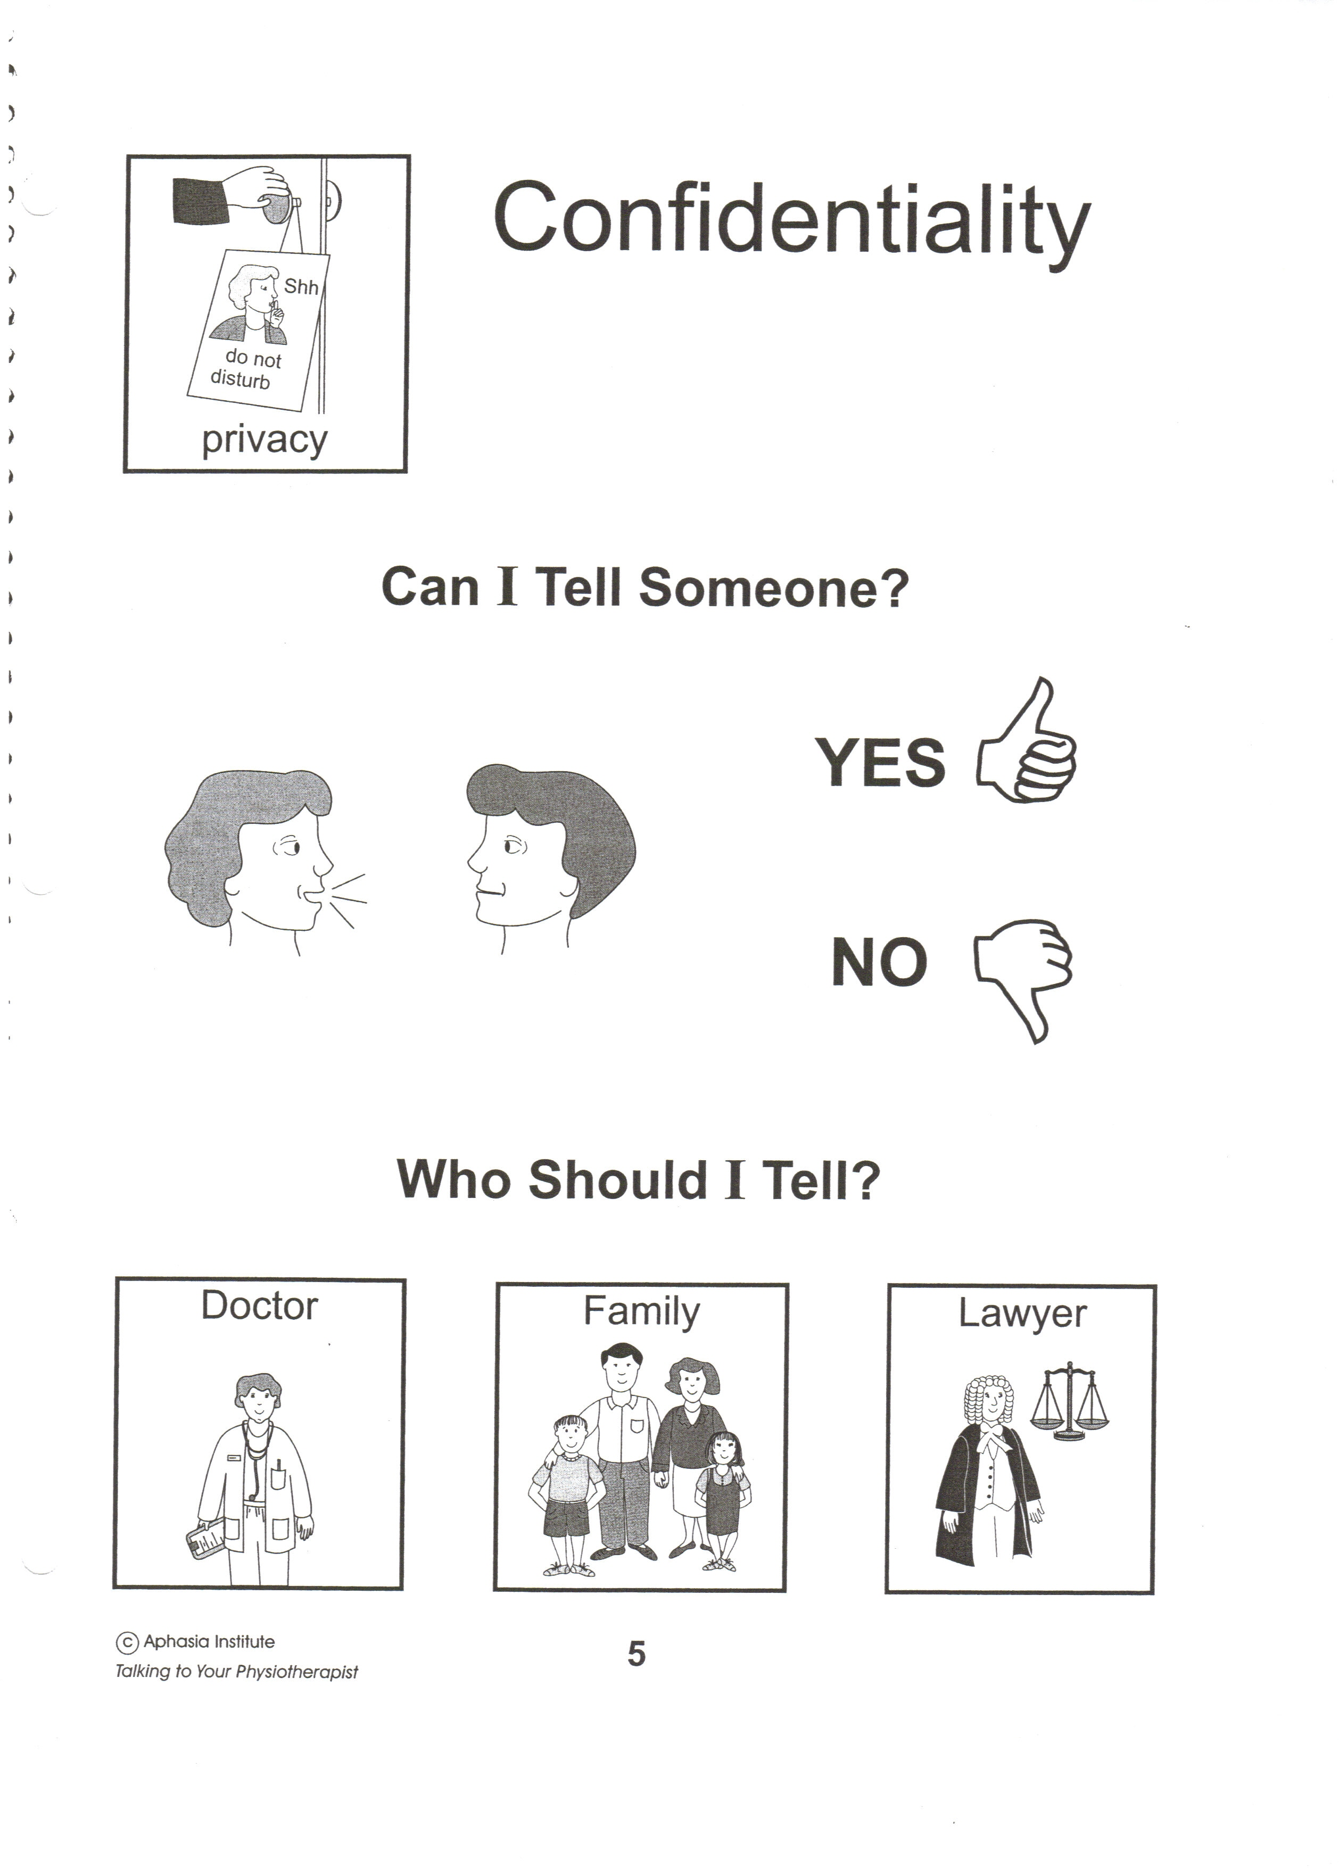
- RPN’s, PSW’s and Volunteers accompany designated clients on outings to ensure accessibility and safety during outings.
- An electronic bill board was installed on Bathurst Street promoting Baycrest Programs and Services.
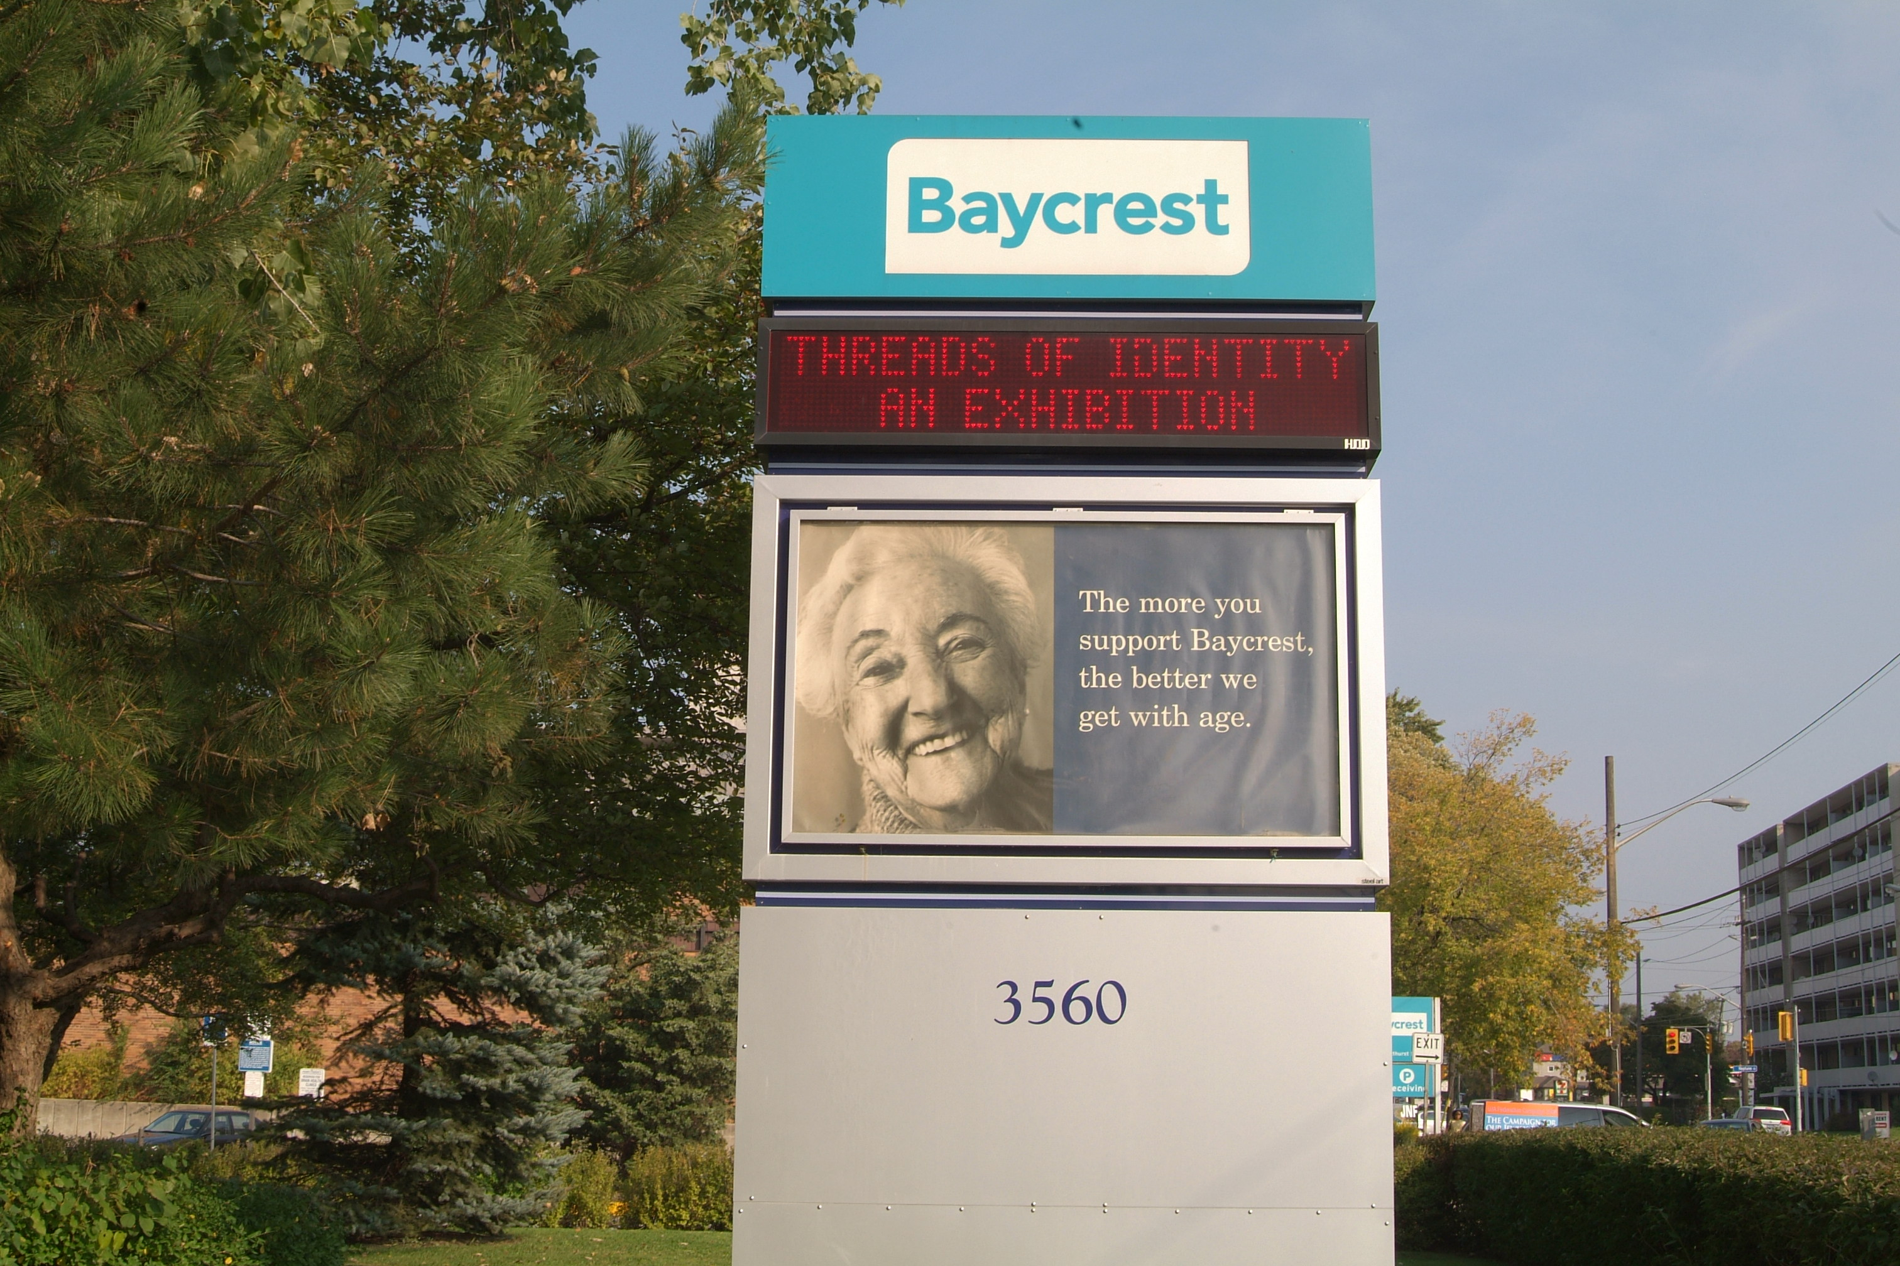

- Elevators throughout Baycrest have been modified so one car in each bank stops on all floors automatically as a Sabbath feature. This feature is also programmed on one Hospital elevator each day for clients who experience difficulty operating elevators.
- An upgraded sound system was installed in the Apotex Winter Garden to allow more clients to enjoy concerts in this area.
- Audiology introduced a system for notifying family members of client clinic appointments to reduce missed appointments.
- An additional exterior intercom system was installed to improve access to the facility after hours and reduce walking time to other entrances.
- A new “Hearing Aid Users Program” was developed by Audiology for first time hearing aid users.
- Hearing services staff provide free monthly hearing aid checks directly on the client care floors together with staff training.
- A Community Resource Manual was developed to identify all of the Physio programs.
- Baycrest’s O.T staff visits other Seniors facilities to promote Baycrest’s programs and provide presentations on “Self Management”.
- A new Community “Tune-Up” (Return) Program was developed by O.T. for clients in their home.
- “Café Europa”, a Holocaust Survivor social program, was developed, which received external funding and has become a huge success. Transportation was co-ordinated to allow more people to attend.
- Improved lighting was installed in the “Wortsman Hall” so clients could play bingo and participate in other activities requiring increased lighting.
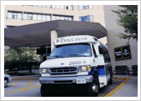
- All Transportation buses are wheelchair accessible for easy client access. A Shuttle Bus service is used throughout the campus grounds to connect buildings.
- A number of virtual care initiatives were started due to the COVID-19pandemic:
- A Telemedicine Rapid Implementation Team to adapt services and support infection prevention measures
- Telepsychiatry
- Virtual discussions with a Baycrest audiologist and virtual group aural rehabilitation classes
- Online group sessions through the Saul and Rae Saltzman Day Treatment Centre
- Virtual mindfulness
- Baycrest@Home – a new project that offers a range of virtual and web-based resources, social worker support, programs and services easily accessible from the comfort and convenience of clients’ homes via phone, video conferencing and the Internet
D) Volunteer Placement
Baycrest has a history of providing volunteer opportunities for persons who have a variety of special needs including; blindness, hard of hearing, mental disorders, physical disabilities, and degrees of learning disabilities. The outcome has been very positive resulting in many long-term volunteer placements.
- For example, volunteers have been used in the cafeteria to assist persons with serving and carrying their trays to their seating area.
- Volunteers are available upon request to assist staff and other volunteers who require special assistance using on-line learning modules.
- Volunteers are placed in various areas of Baycrest such as the Apotex entrance and the Khedive entrance to assist with accessibility upon request.
E) Architectural
- All of Baycrest's building and facilities were built to exceed building code standards for their time. The architectural structure and features within each of the buildings were designed with care and consideration for the population being served. This same approach is used throughout the centre during the planning and construction of renovations.
- The Apotex Centre Jewish Home for the Aged opened in May 2000 and was designed and built with special attention to accessibility issues, examples include: floor surfaces which were chosen to ensure safe and easy mobility, enhanced lighting through both natural and engineered lighting techniques, acoustical treatment to support the hard of hearing, easy to use door handles and other opening devices, wheelchair accessible washrooms throughout the home, automated power doorways, wayfinding design features built into the building structure, room signage, etc.
F) Physical
- Art and design features are an integral part of the environment throughout Baycrest. Particular emphasis is placed on there external environment supports to help compensate for the cognitive changes experienced by many of our clients. Visual cues can help people who are no longer able to evoke images in their own minds. Not all brain functions deteriorate with diseases of the brain. We now know that regions responsible for emotions are better preserved in many forms of dementia. Colour, patterns and shapes may trigger memories and feelings by acting as shortcuts to the emotional centers of the brain. We bear these principles in mind whenever we are installing art or designing interiors so that no two areas will look or feel alike. This acts as nonverbal cueing throughout Baycrest to assist clients with orientation and wayfinding.
• | Wheelchair accessible washrooms are located throughout Baycrest.
• | "User friendly" elevators in the Apotex building with audio floor indication and easy to use controls.
• | Hospital elevator that automatically stops on all floors and permits front and rear entry/exit.
• | A wheelchair accessible ramp is used to connect the main car park to the Main Centre. Accessible parking exceeds code requirements. Special parking arrangements were developed close to building entrances, including short term drop off. “Courtesy” wheelchairs are available at all main entrances for persons who require assistance with walking.
• | Accessible garden areas were designed including elevated garden planters for client use.
• | Fire alarm strobe lights were installed in all Terraces apartments for hard of hearing clients.
• | The exterior entrance curbs were cut at the Kimel Family Building, Apotex and Khedive entrance for improved access.
• | The addition of exterior use heaters to 2 of the Baycrest’s sukkahs provides increased access for clients during bad weather.
• | The installation of sun shelters and awnings has provided improved access to outdoor areas during sunny periods.
• | There is an annual program to grind or hydraulically lift exterior concrete walkways that pose an impediment or trip hazard.
• | The 2nd floor Hospital rooftop garden is fully wheelchair accessible including the entrance door, tables, the deck surface, etc.  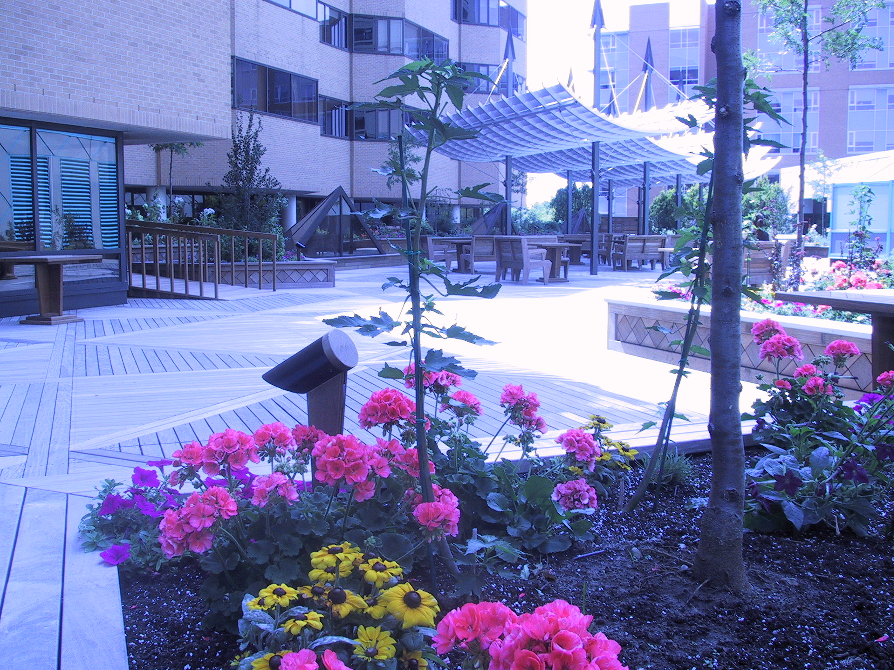
- The entrance door to the Terraces of Baycrest Dining Room has an automatic door opener.
- Auto door openers were installed at the Wagman Centre east entrance door, Apotex entrances, Bathurst entrance and Khedive entrance.
- Replacement automatic powered sliding doors were installed at the Bathurst and Kimel Family Building main entrances.
- Thirteen (13) new “special needs” parking spots were designated in the main car parking lot to provide for closer access to the main buildings. All parking lots are routinely maintained to ensure that accessible parking is clearly indicated. This maintenance includes painting lines; and repairs to address potential hazards (such as pot holes).
- The height of the benches at the main entrances was adjusted to assist persons with mobility impairments.
- The Terraces of Baycrest fire speakers were modified and upgraded to improve volume and clarity for persons with hearing loss.
- The concrete sidewalk area leading to the Apotex Centre main entrance was cut and sloped to provide for better access for persons with sight impairments, wheelchair and walkers.
- Stop signs were installed to better control vehicular traffic at Baycrest’s Shipping/Receiving area.
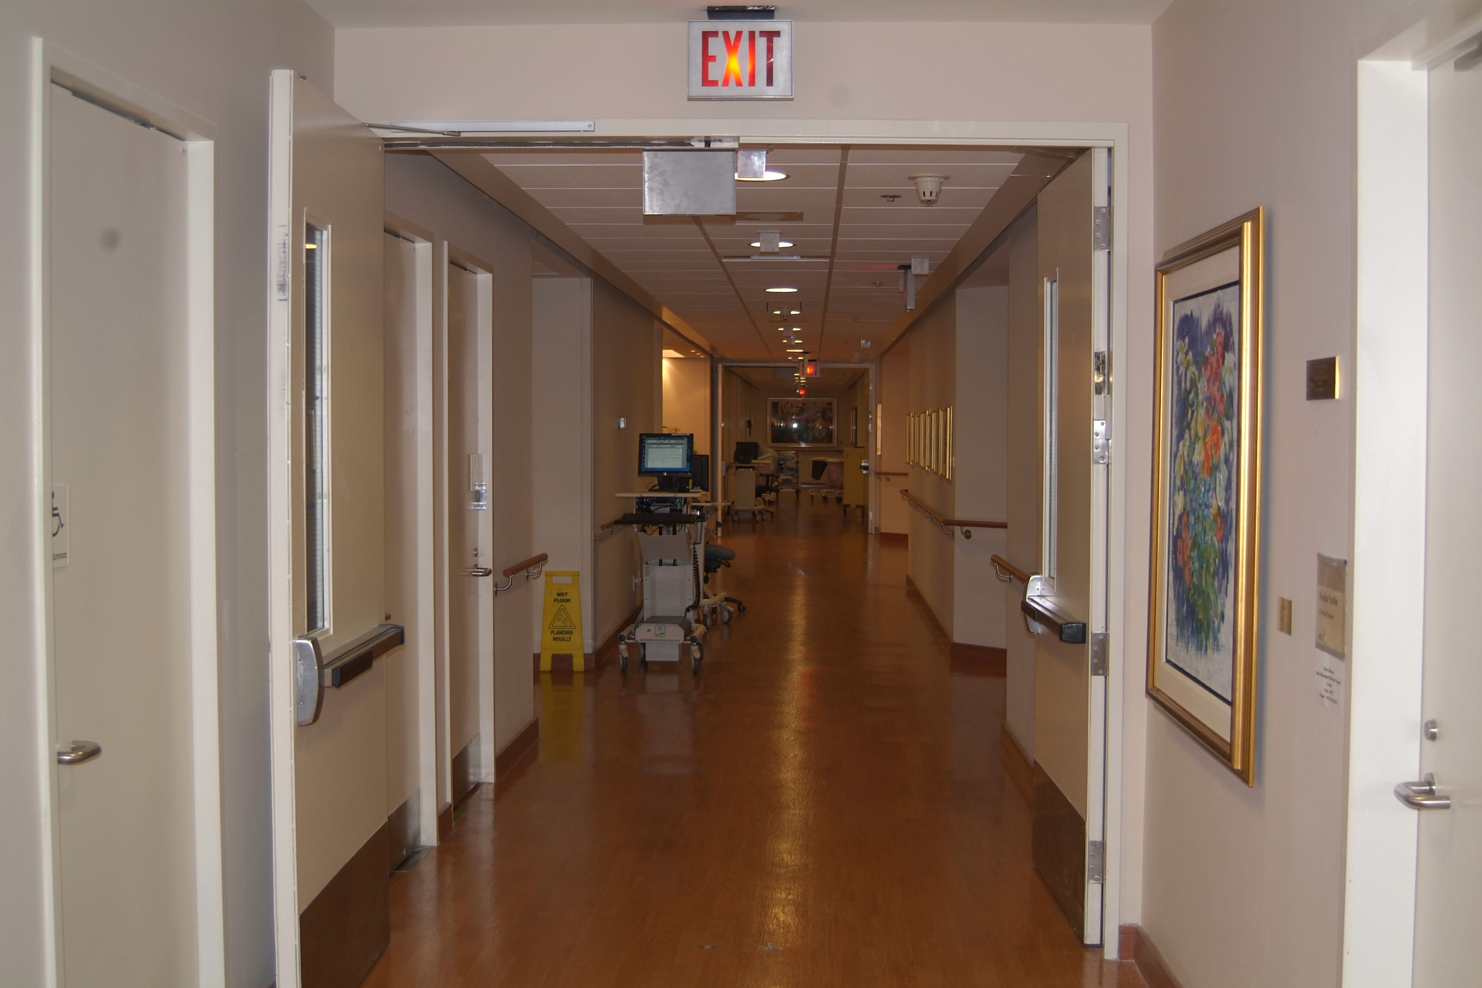
- Extensive renovations to the Hospital’s Palliative Care unit included features such as: large flat screen wall mounted TV’s, improved lighting, water feature, family shower, pedestal sinks, laminate flooring, more user friendly handrails, simplified signage, new furniture (inc.family recliner chair), private activity room and powered door in the meeting/family room.

- Renovations to the Hospital east ground floor washrooms were made to improve accessibility.
- New touchless actuators were installed at the entrance of Baycrest Hospital Entrance #2.
- New accessible door to enter Health Records Office on the second floor of Baycrest Hospital.
- The door of a washroom in Volunteer Services was adjusted to have a slower closing time in order to provide easier access.
- A cafeteria renovation included accessible seating.
- Renovations to the Kimel Family Building included the following features: two new accessible washrooms (including door actuators, one bariatric toilet, and accessible signage); accessible seating in the waiting area; a tactile surface area as part of the interior lobby stairs; and the floor tiles were selected to assist those with cognitive disabilities.
G) Informational and Communication
- Baycrest provides a variety of communication mechanisms which are tailored to ensuring people have access to messaging. An extensive review of the many posted paper signs in the Apotex was done to eliminate clutter and create a more home like environment.
- The Baycrest website is a primary source for a variety of audiences. It includes an extensive Family site which allows people to access information on events, policy changes, and other important information.
- To ensure that information media is user friendly for persons with disabilities, improvements were made to the Baycrest Intranet Internet Website, as well as the main telephone messaging system.
- Switchboard staff (Communication Attendants) were provided training to enhance their ability to communicate with hearing and cognitively impaired persons. This included the telephone, public address system, and face-to-face interaction.
- Pocket Talker amplifiers are available on loan in Audiology and are in use in many areas of Baycrest.
- Soundfield FM systems are used to facilitate hearing for group participants in the Community Day Center and the Terraces.
- An individual FM system was purchased for use by hard of hearing clients, to supplement those already on loan in Audiology.
- Hospital clients are provided with T.V pillow speakers for improved access to TV’s.
- The main floor public telephones were replaced and upgraded to include features to help the hard of hearing, for sight and mobility impairments, and for wheelchair accessibility. These included pay, taxi and courtesy telephones.
- The common area televisions used throughout Baycrest were programmed to include “close captioning” as the standard option.
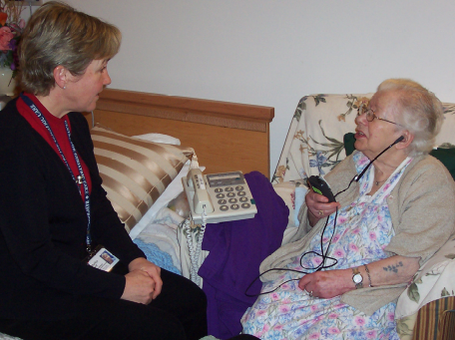
- Clear, contrasting, protruding “street signs” identifying service shops in the Apotex were installed.
- Baycrest’s “Branding” project included new exterior sign faces with improvements to wayfinding upon arrival at the site.
- Increased demand for internet access in resident’s rooms has resulted in an evaluation by I.T. for providing outlets in client rooms.
- Improved elevator intercoms were installed in 5 elevators to improve communication during emergencies.
- Nursing/I.T. replaced the direct care floor wireless phone system to improve nursing response to call bells.
- Physiotherapy, Occupational Therapy & Therapeutic Recreation assessment forms & posters were designed with easily read font and with pictoral diagrams for easier use.

11. Appendix “D”

Frequently Asked Questions
1. | If I want more information about accessibility planning at Baycrest, who can I contact?
 | If you are interested in receiving more information, or need this information in another format, please e-mail webmaster@baycrest.org or call Baycrest Marketing & Communications at (416) 785-2500 ext. 6630. We will be happy to assist you.
2. | Where can I get more information on the Accessibility for Ontarians with Disabilities Act?
Additional information, including backgrounders and Frequently Asked Questions, is available from:
Accessibility for Ontarians with Disabilities Act
Contact Centre (Service Ontario)
Toll-free 1-866-515-2025
TTY 416-325-3408 / Toll Free: 1-800-268-7095
Fax: 416-325-3407
Or visit their web site: Ontario.ca/AccessON

