eLearning Process Guide


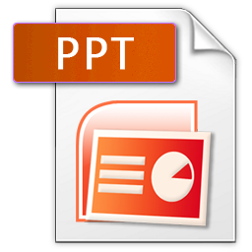

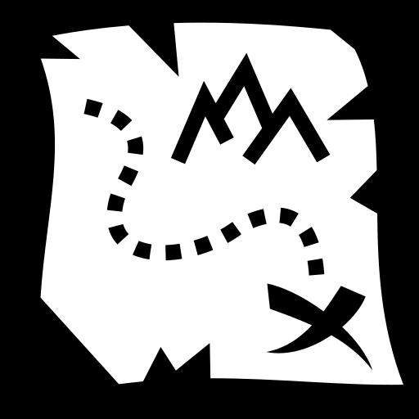

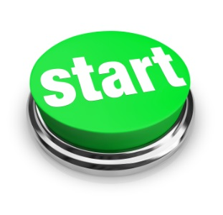
Complete the eLearning Project Request Form
eLearning Process Overview
eLearning Process Overview



Evaluate
Live in LMS

Action Mapping


Review & Revise


Storyboard



Pilot
Review & Revise
Design & Development


Start
To begin complete the eLearning Project Request form found on the intranet at and submit via email to cplunkett@baycrest.org. Projects will be prioritized based on legislative/regulatory/ministry requirements, organizational goals, and breadth of staff affected.
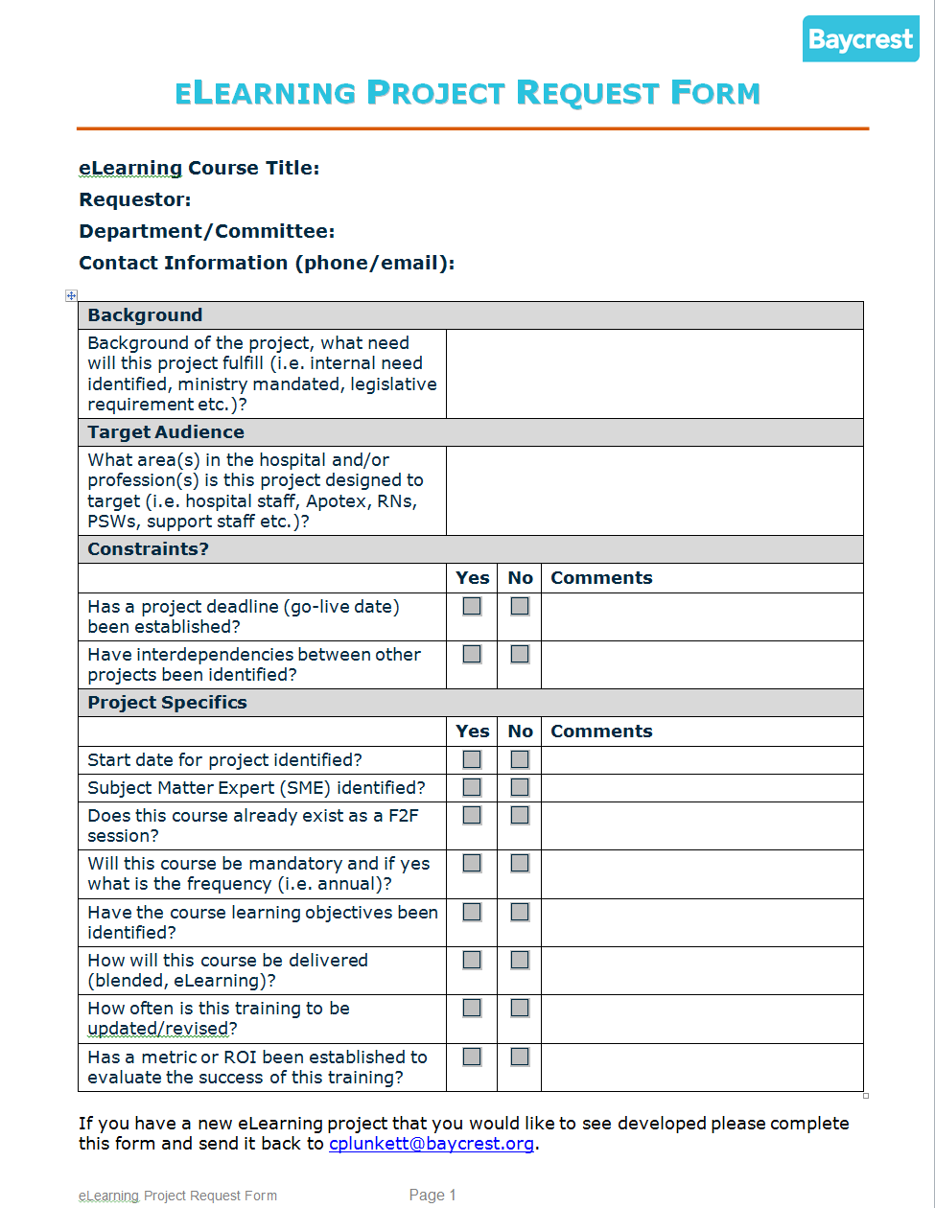


To begin Phase 1 the Project Manager, eLearning and Educational Technologies will assign an eLearning Instructional Designer (ID) to your project. They will then set up a meeting with the Requestor and Subject Matter Expert (SME). During this meeting the group will:
Phase 1: Action Mapping
(adapted from Cathy-Moore.com)
- Review and clarify the process
- Identify roles and responsibilities of the ID and SME
- Engage in Action Mapping the content
- Discuss and confirm delivery method for the material; not all material is recommended for eLearning, alternatives may be suggested
- Review Storyboarding process in preparation for Phase 2
- Discuss deadlines and set future phase meetings
eLearning Instructional Designer (ID) Roles & Responsibilities
- Partner with the SME throughout the process
- Offer guidance in the completion of the storyboard template
- Provide expertise in eLearning instructional design & development
- Ensure content is designed to focus on learning and performance outcomes
- Manage the project efficiently maintaining timelines where possible
- Deliver interactive, engaging, superior quality eLearning materials
Subject Matter Expert (SME) Roles & Responsibilities
- Participate in Action Mapping
- Identify desired learning outcomes using Bloom’s Taxonomy Action Verbs
- Provide content expertise
- Complete the storyboard template within agreed upon timelines where possible (failure to do so will impact the final go-live date)
- Review and detail revisions required to draft version(s)
- Identify Pilot group of frontline learners
- Gather and detail revisions based on Pilot feedback

Action Mapping Overview
Phase 1: Action Mapping
(adapted from Cathy-Moore.com)
Action mapping is a method that focuses on solving performance problems. eLearning is not training on demand, it is a tool to improve people’s performance so that the organization meets its goals. An action mapped course:
- Is created to help develop skills you need on the job
- Is part of a larger solution to a real performance problem (other parts might be policies, job aids etc)
- The material is aimed at you in your job
- It feels like a stream of activities, not a presentation. From the very beginning you are plunged into an activity rather than “prepared” with an information dump.
- You pull the information you need in order to make a good decision.
- The decisions you are required to make are the same decisions you face on the job
- The material is interesting because it is challenging and relevant
- You are treated like an adult

6 Steps
- Ask WHY. Why do you need this course? Talk about the learning need:
- What problems are you seeing?
- How long has it been going on?
- What have you tried in the past?
- Set measurable learning outcomes. For the learning outcomes to work they need to be specific, measurable, and time-bound. Questions that can help identify a measure:
- What are you currently measuring?
- How will this measure change if this project is successful?
- If you’re not currently measuring anything now, how could we measure?
- How will we know we’ve succeeded?
Soft skills can be difficult to measure here are some measurements that may be useful:
- Employee engagement survey results
- Employee retention rates
- Customer satisfaction rates
- Absenteeism
Phase 1: Action Mapping
(adapted from Cathy-Moore.com)
- Legal complaints
- Incident Reports
- Identify what people need to DO. Action, not knowledge, changes performance. Identify the real-world-actions (on the job behaviours) that people need to take to achieve the learning outcomes. Actions are specific observable behaviours; we are focusing on observable behaviours that occur on the job not “test” behaviours.
- Identify why the learners are not currently doing the behaviours:
- Environment: inefficient procedures, insufficient support, insufficient equipment etc. **training is unlikely to fix environmental problems
- Knowledge **sometimes the best solution isn’t a full eLearning module but instead micro-learning videos
- Skills
- Motivation **this is often a side-effect of one of the 3 preceding types
- Design Experiences, NOT information. Knowledge alone won’t reach your goal; people have to take action. Your goal is to help them practice that action. To do that we design experiences, not information. This type of design helps people learn from experience in a safe but realistic setting. Knowing your target audience is crucial, identify: age, education level, interests etc.
- Evaluate it in the Real World. By starting with measurable learning outcomes you’ve baked evaluation into the project. Also be sure to measure the program itself through evaluation.

Let’s Action Map!!
**instructional video and template to come

Storyboarding Your Content
Phase 2: Storyboarding
Storyboard Meeting
The storyboard meeting is scheduled during the Phase 1 Action Mapping. During this meeting:
- completed storyboard template is delivered (* if there is an existing PPT for course delivery this can be used as the starting point for the storyboard)
- content is reviewed and clarified
- design elements will be discussed:
  - themes
  - colour
  - music
  - images
  - narration
  - video
  - interactions
  - scenarios
- learning outcomes will be reviewed and acceptable evidence determined
- delivery date for Review & Revise phase will be set

The ID will now take all of the information from the Phase 1 Action Mapping and the Phase 2 Storyboarding and apply evidence-based best practice principles to create the eLearning/educational technology materials as discussed. This may be in the form of info graphics, micro-learning, blended learning or an eLearning solution(s).
Phase 3: Design & Development

Once the Design & Development is complete the ID will post a draft version of the eLearning solution for the SME to review and send a copy of the design storyboard in MSWord.
Phase 4: Review & Revise
During this phase:
- Pilot date will be set based on the SME’s availability
- Pilot group will be determined by the SME/Stakeholder
- the SME will review and document revision requests in the MSWord design storyboard provided
- all other stakeholders in the project will review and document revision requests in the MSWord design storyboard provided
- the Checklist for strong learning design will be reviewed
- the Project Manager eLearning and Educational Technologies will QA the project using the QA Checklist
- the ID will take ALL of the consolidated feedback/revisions and revise the content in preparation for the Pilot Phase
During the Pilot Phase a sample group of front line users identified by the SME/stakeholder will evaluate and provide anecdotal feedback for the eLearning solution(s).
Phase 5: Pilot
The SME will collect and collate the feedback for deliver back to the ID at the end of the Pilot.

Once the Pilot Phase is complete the ID will review ALL of the consolidated feedback/evaluations with the SME and determine the last round of revisions to the content in preparation for the content being posted Live in the LMS.
Phase 6: Review & Revise

Once the Review & Revisions are completed from the Pilot Phase the module is ready to be posted Live in the LMS. During this phase the following tasks must be completed:
Phase 7: Live in the LMS
- all sources files must be transferred and stored on the central LMS folder
- all final published files must be transferred and stored on the central LMS folder by the ID
- The ID and SME must complete the LMS Course Creation – Online Training form and submit the LMS Administrator

- the course will be turned on live in the LMS
All learning content will be evaluated. eLearning content posted in the LMS will automatically be evaluated – evaluations will be mandatory to successfully complete each module.
Phase 8: Evaluation
Evaluations will be collated for module review and revision 6 months after a module goes live and then annually thereafter.
Attached is a sample course evaluation. This evaluation should be tweaked with the SME to ensure it accurately captures the modules intent.

